**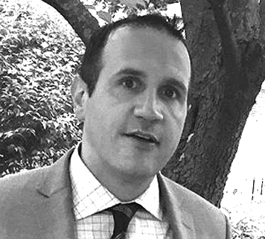*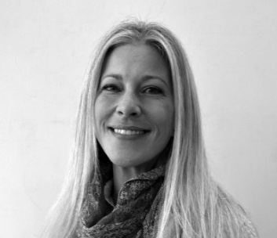***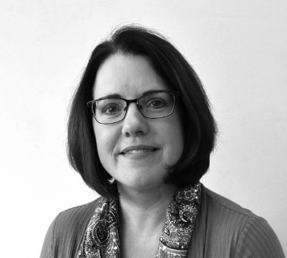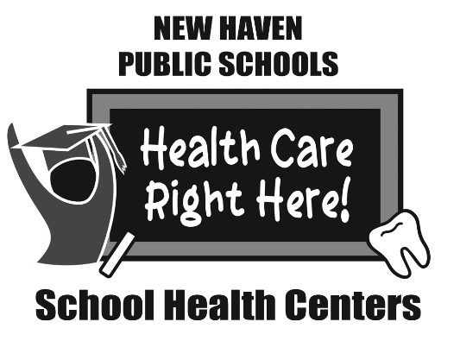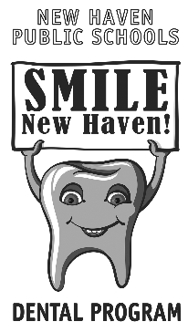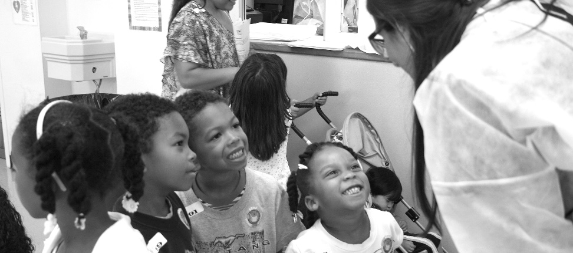

**Richard DelVecchio, DDS**

BIO: Graduate of NYU School of Dentistry. Completed my residency at St. Mary’s Hospital, where I gained valuable experience in all facets of dentistry. Over the years, also volunteered with numerous dental outreach programs.

**Elicia Lupoli, RDH B.S.***Barnard, Brennan-Rogers & King Robinson*

BIO: Graduate from Fones School of Dental Hygiene in 2002. Volunteer for CT Mission of Mercy, member of American Dental Hygienists’ Association, and have served in many other roles within Dental Hygiene.

**Tracey Oberg, RDH B.S.***Hill Central, Troup & Truman*

BIO: Graduate of Tunxis Dental Hygiene 2011. Earned my B.S. in 2017. Have over 20 + yrs experience in the dental field, in many capacities.

**Stop by the School Based Health Clinic and enroll your child for dental services TODAY!  
For any questions about the Dental Program, email Sue.Peters@new-haven.k12.ct.us**

**HOW TO ENROLL A CHILD IN SMILE NEW HAVEN! DENTAL PROGRAM:**

Dental permission forms can be obtained at your child’s School Health Center or from the Dental Hygienist. Parents must complete one form for each child at that school.

**HOW DO SCHOOL DENTAL SERVICES HELP?**

• Little or no missed school time for students

• No missed work time or parents

• No transportation problems

• No language barriers

• Continuity of care

• Better dental health – fewer cavities

**Our Dental Clinics, part of the School Health Centers, feature state-of-the-art oral health equipment, modern dental materials and supplies. Services provided to enrolled students regardless of their insurance status and include:**

• Dental examinations /school wide screenings

• Prophylaxis (cleanings)

• Fluoride treatments

• Sealants

• Radiographs (x-rays)

• Assessment and referrals for walk-in conditions

• Oral health instruction & education

• Referrals made for other specialized services

• Fillings and simple extractions

**Dr. Richard Delvecchio, Dentist, Tracey Oberg, Hygienist** and **Elicia Lupoli, Hygienist** are the NHPS dental program providers who come to your school on a rotating basis.

***Did you know your school had a DENTAL CLINIC?***